Imidacloprid

582

582/TC/M2/-

Method Extension for Imidacloprid UL

Studies for Method Extension of existing CIPAC method for Imidacloprid UL.

By  
Kevin King  
Clarke Mosquito Control  
Analytical Laboratory  
675 Sidwell Ct, St. Charles IL, 60174

1. **Introduction**The CIPAC 582/TC/M2/- imidacloprid method was extended to the UL formulation type, that contains imidacloprid, with a few minor modifications. This report was prepared to demonstrate the validity of the extension of the CIPAC 582/TC/M2/- for Imidacloprid UL formulations.
2. **Method Description**  
     
   **Imidacloprid Formulation Extension method of CIPAC 582/TC/M2-**

**Outline of CIPAC Method**: Imidacloprid is determined by reversed phase high performance liquid chromatography using UV detection at 260nm and external standardization.

**Reagents**

*Imidacloprid* reference standard with known content

*Water* HPLC Grade

*Acetonitrile* HPLC Grade

*Buffer pH 3* 0.1M sodium citrate – hydrochloric acid (c(HCl) = 0.1mol/L), 40 + 60 (v/v); e.g. Titrisol Merck art no. 109883

*Eluent* water – buffer solution – acetonitrile 72 + 8 + 20 (v/v/v)

*Calibration Solution* Weigh in duplicate (to the nearest 0.1mg) about 75mg of the imidacloprid standard (s mg) into separate volumetric flasks (100mL). Add acetonitrile (about 30mL) and place the flasks in an ultrasonic bath for 15min. Add water to just below the mark and mix. Allow to cool to ambient temperature and fill to the mark with water (Solutions C1 and C2).

**Apparatus**

*High performance liquid chromatograph* equipped with an ultraviolet spectrophotometric detector and an injection system capable to inject 5µL

*Column* stainless steel, 125 x 4mm (i.d.), packed with Licrhospher RP 18, 5µm, or equivalent material with the same selectivity

*Electronic Integrator*

*Ultrasonic bath*

*Centrifuge* or *Disposable filters*, solvent compatible, porosity 0.45µm (e.g. Gelman GHP ACRODISC or equivalent)

**Procedure**

* 1. *Chromatographic Conditions (typical)*

|  |  |
| --- | --- |
| **Parameter** | **Specification** |
| Column Temperature | 40 ºC |
| Flow Rate | 2.0 mL/min |
| Measuring Wavelength | 260 nm |
| Injection Volume | 5 µL |
| Run Time | Approx.. 10min |
| Retention Time | Approx. 2.5min |

* 1. *Equilibration of the system*  
     Pump sufficient eluent through the column to equilibrate the system. Inject 5µL portions of the calibration solution C1 and repeat the injections until retention times and peak areas vary by less than ±0.5% of the mean for three successive injections.
  2. *Sample preparation*Weigh (to the nearest 0.1mg) sufficient sample to contain about 75mg imidacloprid (*w* mg) into a volumetric flask (100mL). Add acetonitrile (about 30mL) and place the flask in an ultrasonic bath for 15min. Add water to just below the mark and mix. Allow to cool to ambient temperature and fill to the mark with water (Solution S)
  3. *Determination*Inject 5µL portions of the calibration solutions (C1 and C2) and of the sample solutions (S1, S2, …, etc.) in the following sequence:  
     C1,S1,C2, S2, …  
     Determine the peak area of imidacloprid and calculate the response factors (*f*) from the calibration solutions bracketing the injections of the sample solutions. Average the response factors of the calibration solutions preceding and following the sample solution injections. These must agree within ±0.5% of the average otherwise repeat the determination. Calculate the content of the sample solution.
  4. *Calculation  
       
     f* = *s* * *P* / *Hs*   
       
     Imidacloprid content (g/kg) = *Hw* * *f* / *w*   
       
     Where:  
     *f* = mean response factor  
     *Hs* = peak area of imidacloprid in the calibration solution  
     *Hw =* peak area of imidacloprid in the sample solution  
     *s* = mass of imidacloprid in the calibration solution (mg)  
     *w* = mass of sample taken (mg)  
     *P* = purity of imidacloprid standard (g/kg)

1. **Method Assessment**  
   According to the CIPAC method extension guideline, the method extension of the CIPAC 582/TC/M2/- for imidacloprid technical was investigated.  
     
   One UL formulation, CMP123-004, was subjected to this assessment. The nominal content of imidacloprid in the UL formulation tested is 30 g/kg.  
   1. **Check the availability of a CIPAC method for the formulation concerned (Step 1)**  
      The formulation of interest is a combination active ingredient formulation. There is no existing CIPAC method available for the UL formulation type containing imidacloprid. The formulation of interest, CMP123-004, contains imidacloprid. The method extension of CIPAC 582/TC/M2/- was investigated.
   2. **Check whether the concentration of the analyte is inside or outside the acceptability range covered by the samples of the original trial (Step 2)**CIPAC 528/TC/M2/- does not have a range, there is no analysis of linearity. The method is determined to be used for a technical grade with an active ingredient content of 985 g/kg.   
      The formulation of interest has a nominal imidacloprid content of only 30 g/kg. However, when the sample was prepared, it was prepared to have an imidacloprid concentration of 0.75mg/mL such that it is the same concentration as described in the existing CIPAC method.
   3. **Modification of method has to be changed in order to be specific (Step 4)**  
        
      In order to apply the CIPAC 582/TC/M2/- methodology to the formulation of interest, CMP123-004, a modification of the run time was required.  
      When injecting the finished product formulation, the blank (the solvent of the product) had a peak which would elute at 24minutes of run time. In order to ensure that this blank peak did not carry over into the following injection, the run time of the HPLC analysis was increased from 10 minutes to 30 minutes. This increase in run time has no impact on the quantification or analysis of imidacloprid in the formulation.  
      This modification is considered to be a minor modification.
   4. **Validation study (Step 5)**  
      Specificity, and precision (repeatability, r) tests were conducted.
      1. **Specificity**The sample solutions and a blank solution were prepared identically. A comparative (refer to chromatogram figures) evaluation of the sample solution, blank solution, and the standard solution show that there is no interference with the analysis and quantification of the imidacloprid active.
      2. **Precision (repeatability, r)**The UL sample was prepared in 5 replicates (5 separate sub samples) and analyzed according to the specified chromatographic conditions with the exception of the increased runtime noted in section **3(C)**. Per the Horwitz equation, the acceptable %RSD for a sample with a nominal 3% concentration is as follows:  
           
         %RSD = 2 * C-0.15  
           
         C = concentration of analyte expressed as a decimal.  
           
         For a 3% concentration, this equates to (2 * 0.03-.15) 3.384%. As shown in the table below, the repeatability of this method was satisfactory with a %RSD of 0.74.

|  |  |
| --- | --- |
| **Replicate** | **Imidacloprid Content (g/kg)** |
| 1 | 30.10 |
| 2 | 29.72 |
| 3 | 29.87 |
| 4 | 29.59 |
| 5 | 29.57 |
| **Avg** | 29.77 |
| **%RSD** | 0.74 |

1. **Conclusion**In order to apply the CIPAC 582/TC/M2/- to UL formulations containing imidacloprid, the method required an increase in the analytical run time of the HPLC injection. This is considered to be a minor modification.  
     
   The data shown demonstrates that the method is specific and has acceptable precision (repeatability, r). Therefore, the modified method is considered appropriate for the determination of imidacloprid in a UL formulation and the extension of CIPAC 528/TC/M2/3- to UL formulations is proposed by Clarke.

**Figure 1. Injection of Diluent**

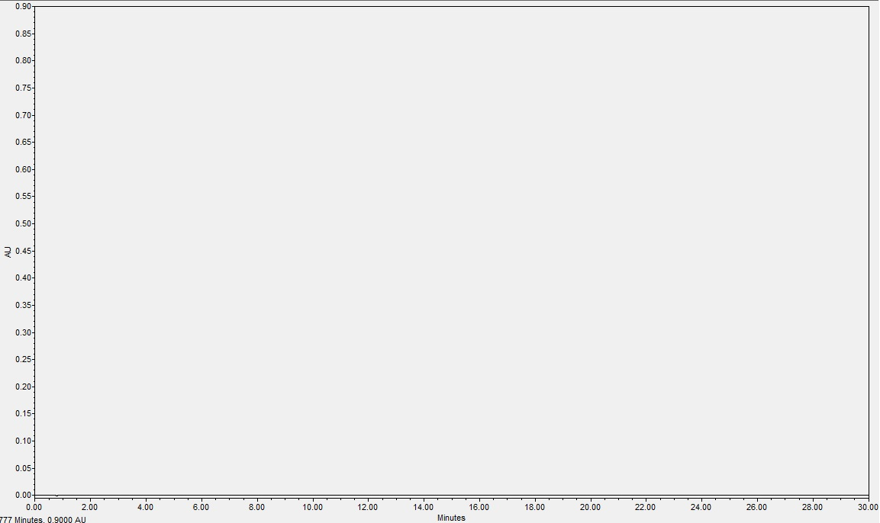

**Figure 2. Injection of Blank preparation**

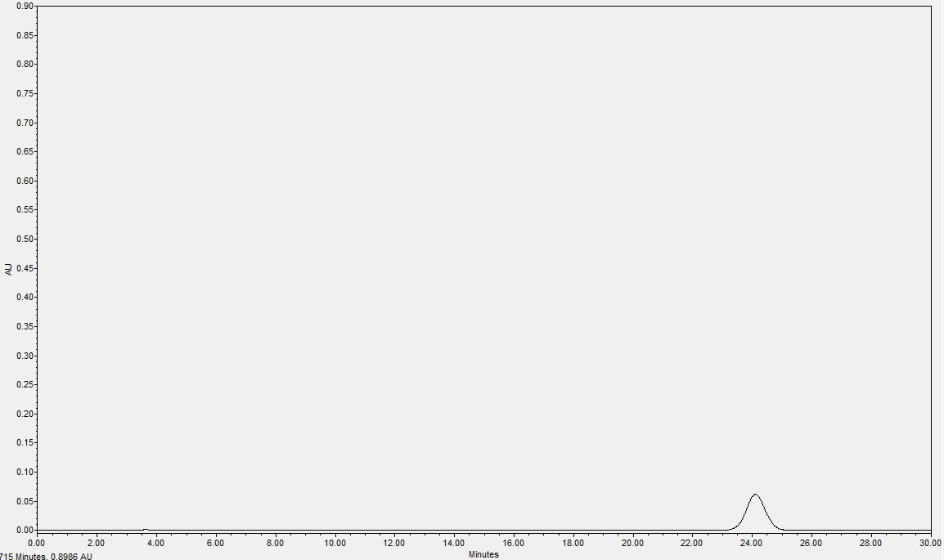

**Figure 3. Injection of Calibration Solution**

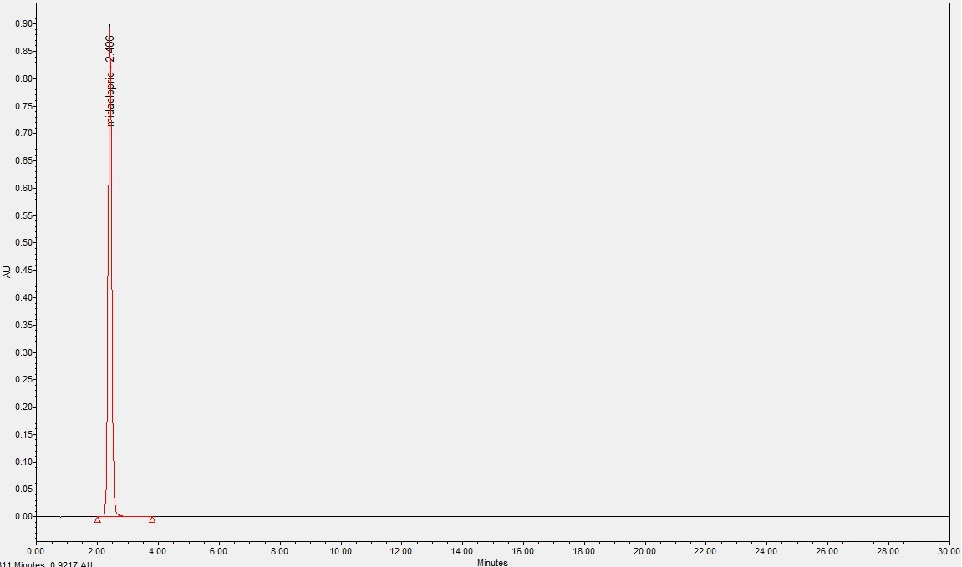

**Figure 4. Injection of Sample preparation**

